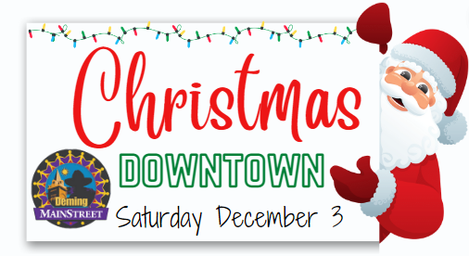

2022
Light-up Downtown Business Registration
2022
To encourage Christmas spirit in Downtown Deming, the Deming Luna County MainStreet Program will be hosting its 3rd annual Light-up Downtown Contest with cash prizes to the best decorated storefronts!
Prizes:
1st $500 2nd $300 3rd $200

Contest Details:
You will be judged on the following criteria:

1. Christmas spirt
2. Creativity
3. Overall appearance

The Light-up Downtown contest will kick-off Saturday, December 3, 2022. Judging will take place on Saturday, December 10, 2022, beginning at 6pm. Keep an eye out for the judge's limo!

Eligibility:
To participate in the Deming Luna County MainStreet Program Light-up Downtown Contest you must have a storefront located in Deming.

Business Information

Business Name: __________________________________ Contact Person: ____________________________

Business Address: _________________________________ Phone: ___________________________________

Email Address: _____________________________________________________________________________
Would you like to be added to the Deming Luna County MainStreet Program email list?
☐Yes, small business information. ☐Yes, project/events update. ☐Yes, please both lists!
☐No, thank you. ☐I’m already signed up!

