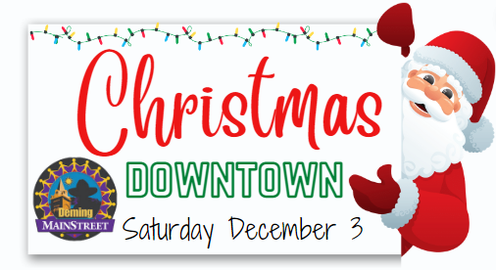
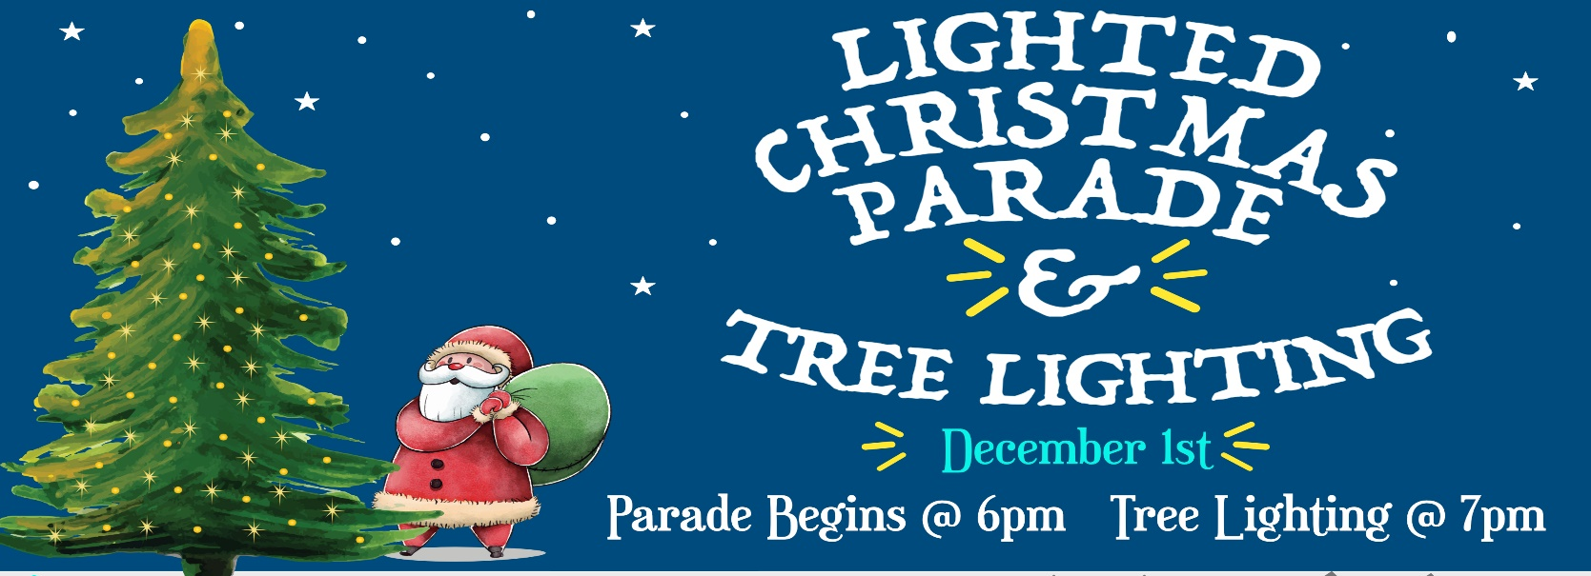
Lighted Christmas Parade Entry Form

2022
Category: □ Float □ Car(s)/Truck(s) □ Walk/March □ Band
December 4th

□ Horse □ Tractor □ Other: ____________________________________

Number of Vehicles:________ Name of Individual/Group:____________________________________
2022
Address:___________________________________City:_____________State:________Zip:_________
Contact Person:_____________________________ Phone:___________________________________
Email Address: _____________________________
Will you be using music as part of your entry? Yes_______ No_______

Entry Fee - $5.00
We accept card, cash, or check. Please make check out to the Deming-Luna County MainStreet Program.

Bring or mail entry form and entry fee to the Deming Visitor Center, 800 E Pine Street.

Deadline for submitting entries is 4:45PM, Thursday , December 1st 2022

I/We hereby hold harmless the Deming-Luna County MainStreet Program, City of Deming, County of Luna and New Mexico Department of Transportation for any and all liability or any and all actions and activities in relation to the parade.

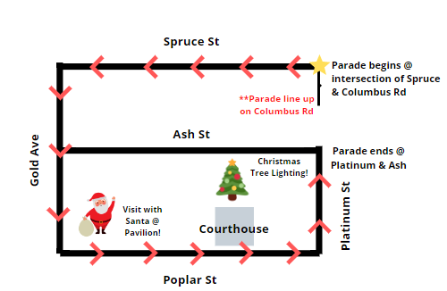
Signature:_____________________________________________ Date: _______/_______/_______
Line-up will be on Columbus Rd along Chicano Park heading north. Beginning at 5pm.

The parade will begin at 6pm from the intersection of Columbus Rd and Spruce St.

